EMERGING METHODS FOR EARLY DETECTION OF FOREST FIRE

MODEL BUILDING

IMPORTING THE MODEL BUILDING LIBRARIES

|  |  |
| --- | --- |
| Team ID | PNT2022TMID34010 |
| Project Name | Project- Emerging Methods For Early Detection of Forest Fire |

IMPORTING THE MODEL BUILDING LIBRARIES:

Import the libraries that are required to initialize the neural network layer, create and add different layers to the neural network model.The below libraries are imported and executed.

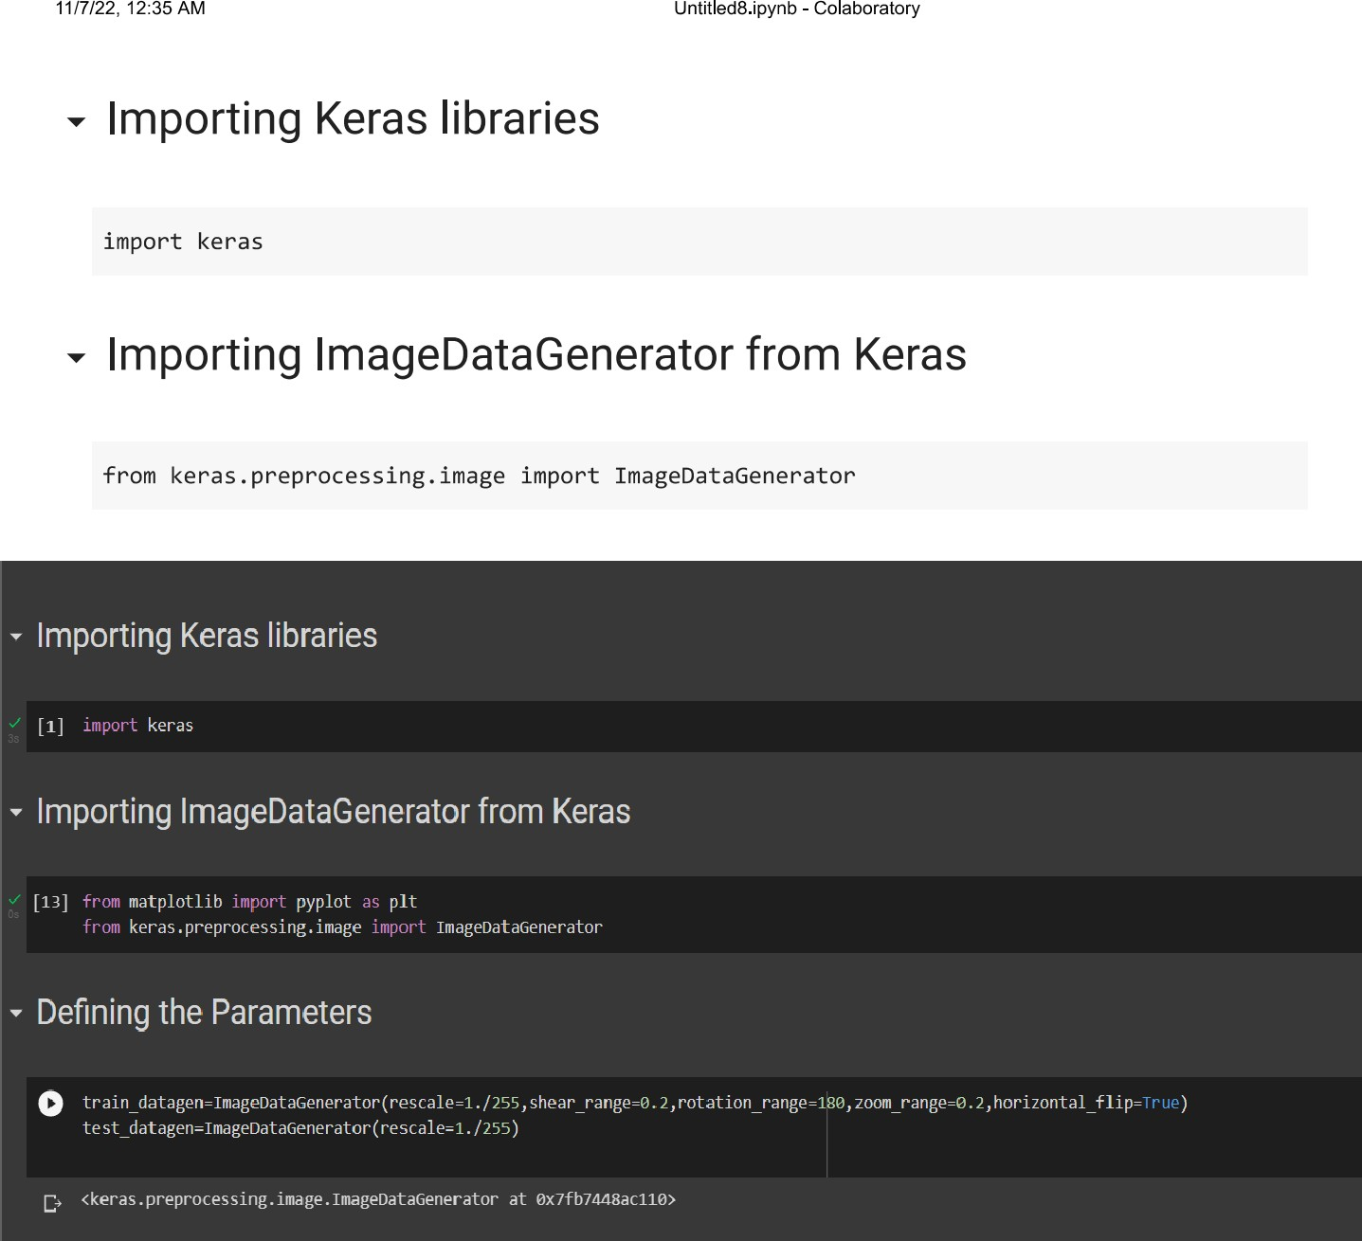

APPLYING ImageDataGenerator to train dataset:

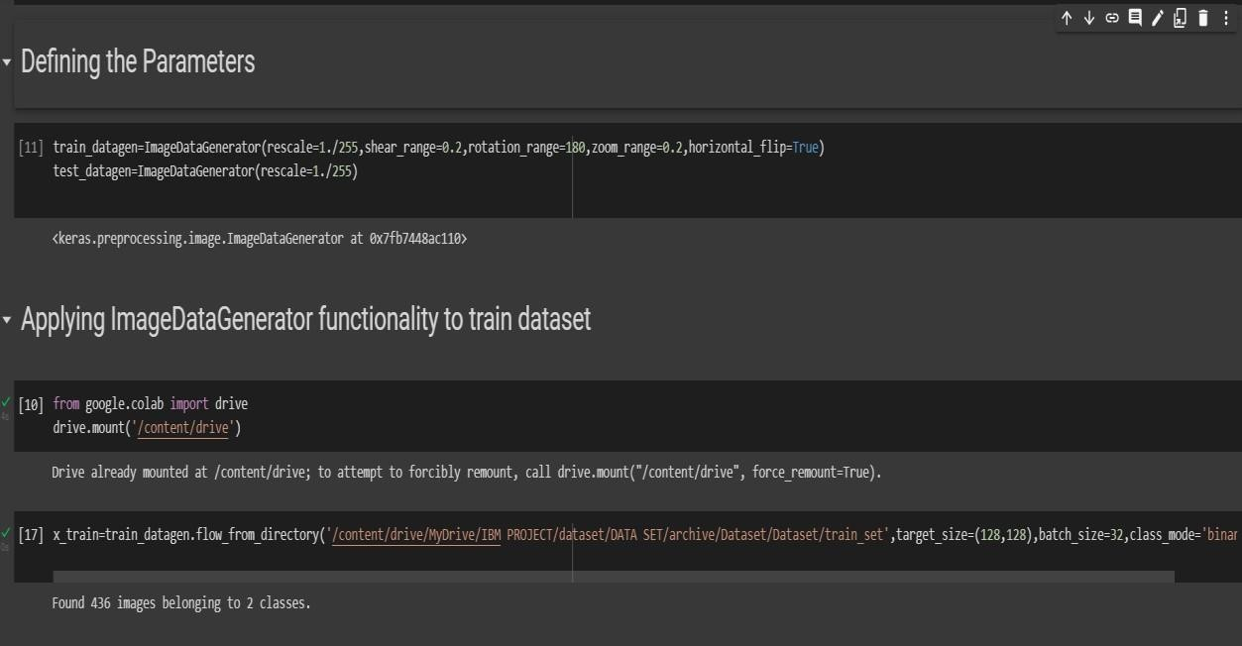ply**flow_from_directory ( )**methodfor Train folder.

APPLYING ImageDataGenerator to test dataset:

Applying the **flow_from_directory ( )** methodfortest folder.

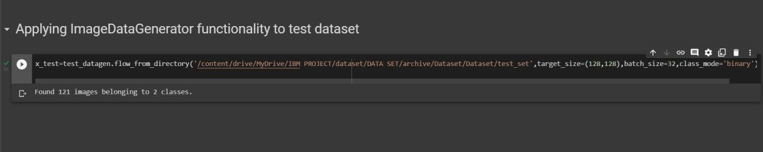

IMPORTING MODEL BUILDING LIBRARIES:

